Project Report on
Smart Irrigation System (IOT based)



Submitted to
Department of Computer Science and Engineering
Nepal Engineering College

in Partial Fulfillment of the
Requirements for the Degree of B.E. in Computer

Submitted By
Aashika Pandey (022-391)
Rubi Adhikari (022-368)
Shristi Dhakal (022-376)

Supervised By: Asst. Prof. Ashish Kumar Jha
Submission Date: 30th July 2025
Abstract
Agriculture is a vital part of every nation's economy and plays a key role in development. However, traditional farming methods, especially manual data collection, are time-consuming and labor-intensive. This project introduces an IoT-based system to automate agricultural data monitoring. Using sensors and connected devices, the system collects real-time field data, reducing the need for human intervention. This not only lowers operational costs but also ensures accurate and consistent data collection. The gathered data is processed to support decision-making, improve resource use, and enable automated control. This smart farming approach aims to boost productivity and make crop management more efficient.

Keywords: [Agriculture,IoT,smart farming,Real-time Monitoring,Crop Management]

Acknowledgement
I would like to express my sincere thanks to our respected teacher, Mr. Ashish Kumar Jha, for providing us with this wonderful opportunity to work on this project. It has been a valuable learning experience that has helped us enhance our knowledge, improve our teamwork skills, and gain practical exposure.
I am also thankful to our senior brothers and sisters, as well as my close friends, for their constant support and for sharing creative ideas that greatly contributed to the successful completion of this coursework report.

Aashika Pandey (022-391)
Rubi Adhikari (022-368)
Shristi Dhakal (022-376)

Table of Contents
Chapter 1: Introduction 1
1.1 Overview 1
1.1.1 Project as a solution 2
1.1.2 Project Description 2
1.2 Problem statement 4
1.3 Aims and Objectives 4
1.3.1 Aims 4
1.3.2 Objectives 5
1.4 Motivation 5
1.5 Scope and Application 5
1.6 Feasibility Study 6
Chapter 2: Literature Review 8
Chapter 3: System Design 10
3.1 Requirement Analysis 12
Chapter 4:Implementation and Discussion 19
4.1 Methodology 21
4.2 Implementation steps 22
4.3 Output Obtained 22
4.4 Testing/Test Cases 25
4.5 Time Schedule 26
Chapter 5:Analysis and Evaluation 29
5.1 Data Analysis 29
Key Findings from Data 29
5.2 Results 30
5.3 Comparison with Objectives: 31
5.4 Discussion of Findings 32
Chapter 6:Conclusion and Future Work 34
References 35

Lists of figures
Fig 1:Flowchart of smart irrigation system 8
Fig 2 : Use Case Diagram of Smart irrigation system 9
Fig 3 : NodeMCU 10
Fig 4 : Soil Moisture 10
Fig 5 : Water pump 11
Fig 6 : Breadboard 11
Fig 7 : Jumper wires 12
Fig 8 : Relay Module 12
Fig 9 : Buzzer 13
Fig 10 : LED 13
Fig 11 : Arduino IDE 14
Fig 12 : Blynk 15
Fig 13 : Flask 15
Fig 14 : Board Diagram of Smart Irrigation System 16
Fig 15 : OUTPUT 21
Fig 16 : Time Schedule 23
Fig 17 : Result 27

List of Tables
Table of test case………………………………………………………………………………………..22
Table of results…………………………………………………………………………………………..27
Table of objective and evaluation…………………………………………………………………...28

Abbreviations
- IoT: Internet of Things
- SAS: Smart Agriculture System
- MCU: Micro Controller Unit
- ESP: Event Stream Processing

Chapter 1: Introduction
A smart irrigation system is an automated solution designed to optimize water usage for agriculture and landscaping by using advanced technologies like sensors, microcontrollers, and the Internet of Things (IoT). Unlike conventional irrigation, which often leads to water wastage, smart irrigation systems monitor real-time soil moisture, and plant needs to deliver the right amount of water only when necessary.
These systems typically use soil moisture sensors and weather data to determine when and how much to irrigate. The sensors send data to a controller, which then activates water pumps or valves as needed. Many smart irrigation setups also allow for remote monitoring and control via mobile apps, enabling users to manage irrigation efficiently from anywhere.
The main goals of a smart irrigation project are to conserve water, reduce manual labor, and maintain healthy plant growth by preventing both over- and under-watering. This technology is especially valuable in agriculture, where it can save up to 50% of water compared to traditional methods, and is adaptable to different crops and soil types.

1.1 Overview
In modern agriculture, efficient water management is crucial for enhancing crop yield and ensuring sustainable farming practices. Our IoT irrigation system addresses this need by automating the irrigation process based on real-time soil moisture levels. The system utilizes a soil moisture sensor to continuously monitor the moisture content of the soil. When the sensor detects that the soil is dry, it triggers a water pump to irrigate the crops, ensuring they receive the necessary hydration for optimal growth. This automated approach not only conserves water but also promotes healthier crop development by providing precise irrigation when needed. At the core of our system is the NODEMCU, an open-source IoT platform that enables easy connectivity and control over the irrigation process. The ESP module facilitates wireless communication, allowing farmers to monitor and manage their irrigation system remotely. Additionally, a relay module is used to control the water pump, ensuring that it operates only when required. By integrating these components, our IoT irrigation system provides an innovative solution for farmers, enhancing crop growth while promoting efficient water usage. This technology represents a significant advancement in agricultural practices, contributing to increased productivity and sustainability in farming.

Project as a solution
The solution of this project is to develop a Smart Agriculture System which helps the farmers with less cost, that makes the field cultivation process much simpler and efficient. The major solution of the problems that this project provides are:
- This project will help maintain the soil moisture by constantly monitoring the soil moisture and watering the plants automatically to the required level.
- In this project we will also be implementing a cloud so that the owner can constantly monitor the field and moisture level of soil
- Sensor allows for water use only when and where needed and this directly helps to conserve water.
- Lowering overall costs in treatment and harvesting can reduce resource consumption and overall costs.
- Increased quality of crop production because of proper scientific technologies measures.

1.1.2 Project Description
This project aims to design and implement a Smart Irrigation System that leverages IoT technology to optimize water usage in agricultural fields. The system is structured around four core modules, each playing a vital role in the automation and efficiency of irrigation management.
Core Modules for this project are:
- Sensor Module:
This module includes soil moisture sensors. It collects real-time environmental and soil data to assess the need for irrigation. The sensors are deployed in the field and communicate data to the processing unit.
- Control Module:
The control module consists of a microcontroller NodeMCU ESP8266, that processes the sensor data. Based on pre-defined thresholds and logic, it decides when to activate or deactivate irrigation systems .
- Communication Module:
Wi-Fi (via NodeMCU ESP8266)In this system, Wi-Fi serves as the primary communication channel that enables the NodeMCU ESP8266 microcontroller to connect to the Internet and interact with cloud services or applications like Blynk.

- User Interface Module: Blynk (Mobile App Platform):
The Blynk platform acts as the User Interface Module, enabling users to interact with the smart irrigation system through a mobile application. It is designed for IoT projects and supports communication with microcontrollers like NodeMCU.

1.2 Problem statement
Traditional irrigation systems are often waste water and are inefficient, leading to overwatering, underwatering, inconsistent watering and environmental impact. Efficient water management is a challenge in modern agriculture, with traditional irrigation methods often leading to overwatering or under-watering, resulting in water wastage, reduced crop yield and increased costs. Farmers face difficulties in monitoring soil levels and managing irrigation schedules effectively. To address these challenges, a smart irrigation system using IoT can be developed to optimize water usage and automate irrigation process. This system leverages sensors such as soil moisture and make data-drive decisions. Using the IoT-enabled devices, farmers can remotely monitor and control irrigation system through mobile or web applications, reducing labor dependency and operational costs.
Irrigation systems often suffer from inefficient water usage due to the lack of real-time monitoring and automatic control. Fixed-schedule watering can result in overwatering or underwatering, leading to water wastage and reduced effectiveness. To address this issue, there is a need for a smart, automated system that can monitor soil moisture levels and control irrigation accordingly. This project aims to develop a Smart Irrigation System using IoT technologies like NodeMCU, soil moisture sensors, and a relay module to automate watering. The system will ensure efficient water use, minimize human intervention, and enhance the reliability of irrigation processes.

1.3 Aims and Objectives

1.3.1 Aims
The main aim of this project is to develop a user-friendly NodeMCU based Smart Agricultural Monitoring and interface, cost and work efficient technology that will benefit everyone involved in agriculture.

1.3.2 Objectives
- To learn about different devices that we are using to build this project like node, soil moisture, water motors.
- To develop a system that can water the soil by monitoring the moisture of soil by using sensors.
- To implement the knowledge of hardware, software and programming language on IOT projects.
- To implement automated irrigation systems that adjust water supply according to crop needs, reducing water wastage.
- To automate the irrigation system.

1.4 Motivation
The increasing population growth and need for food require more effective innovations within agriculture practice. IoT technology in agriculture and irrigation systems, in particular may radically change how we consume the water resources through detailed monitoring, automated responses, and remote control of the irrigation systems. Productivity may increase while reducing cost and saving water resources through IoT systems.

1.5 Scope and Application
For our project, the Smart Irrigation System using IoT, the scope is to automate and optimize irrigation based on real-time soil moisture data. The system is focused on agriculture, helping farmers improve crop yield by using water efficiently. It also has applications in environmental conservation, particularly in areas facing water scarcity, by ensuring sustainable irrigation practices. The goal is to provide an efficient, scalable solution that minimizes water wastage and supports sustainable agriculture and environmental management.

1.6 Feasibility Study
The Smart Irrigation System using IoT is technically feasible with affordable components like NodeMCU, soil moisture sensors, and relays. The system has been successfully set up and tested, though calibration of sensors and relay control still need refinement. Economically, it offers cost savings through efficient water use and labor reduction. Operationally, the system is user-friendly and scalable, but further testing and improvements are required for reliability across various environmental conditions. The project shows promising potential for improving agricultural practices and sustainability.
- Technical Feasibility:
The smart irrigation system is technically feasible as it uses widely available and proven technologies . The NodeMCU ESP8266 microcontroller offers built-in Wi-Fi for internet connectivity and is compatible with various sensors and actuators. The soil moisture sensor used is reliable for field data collection. Programming and integration can be done using the Arduino IDE, which supports all required components. The system architecture is modular and scalable, allowing for easy expansion or customization.
- Economic Feasibility:
This project is cost-effective, especially for small to medium-scale applications. The components are low-cost, and the overall setup requires minimal investment. Operating costs are low due to the automated nature of the system, which reduces the need for manual labor. In the long run, it leads to significant water savings and improved crop yields, which translates to higher profitability. Therefore, the economic benefits outweigh the initial and operational costs.
- Operational Feasibility:
The system is easy to install, operate, and maintain. Farmers and users can monitor and control the irrigation system remotely via the Blynk mobile app. Automation ensures timely irrigation based on actual soil conditions, which enhances efficiency. The system requires minimal user interaction once deployed, and the interface is intuitive, requiring only basic smartphone literacy. With proper setup, the system operates reliably under typical agricultural conditions.

- Legal and Environmental Feasibility:
The system complies with general legal and safety norms, as it does not interfere with any restricted technologies or data-sensitive operations. Environmentally, the system is highly beneficial as it helps conserve water, prevent over-irrigation, and supports sustainable farming practices. By reducing water wastage and improving resource management, the project aligns well with environmental goals and policies.
- Schedule Feasibility
The system can be developed and deployed within a short timeframe. The simplicity of the components and the availability of open-source platforms allow rapid prototyping and testing. A basic version of the system can be completed within a few weeks, with enhancements added over time based on performance and feedback.

Chapter 2: Literature Review
The development of automated irrigation systems that monitor soil moisture and supply water efficiently is increasingly vital in modern agriculture, particularly in the context of water scarcity and the need for sustainable farming practices. These systems leverage advanced technologies, including microcontrollers, sensors, and wireless communication, to optimize water usage and enhance crop yield.[1]
Automated irrigation systems utilize soil moisture sensors to continuously monitor the moisture levels in the soil. These sensors can be based on various technologies, including capacitance and resistive methods. Capacitance-based sensors, for instance, have been shown to outperform resistive sensors in terms of durability and accuracy, making them suitable for long-term use in smart irrigation systems [2]. The integration of these sensors with microcontrollers, such as Arduino or Raspberry Pi, allows for real-time data processing and decision-making regarding irrigation needs [3] . For example, when soil moisture levels drop below a predefined threshold, the system can automatically activate a water pump to irrigate the crops, ensuring that plants receive adequate water without human intervention [4].
Moreover, the deployment of wireless sensor networks (WSNs) enhances the capability of these irrigation systems by enabling the collection of data from multiple sensors distributed across a field. This approach allows for a more comprehensive understanding of soil moisture variability, which is crucial for implementing regulated deficit irrigation (RDI) strategies [5]. By adjusting irrigation schedules based on real-time data, farmers can significantly reduce water usage while maintaining optimal soil moisture levels for crop [6]. The use of solar-powered sensors further contributes to the sustainability of these systems, reducing reliance on external power sources and minimizing operational costs [7].
In addition to traditional soil moisture sensors, innovative methods such as smartphone-based sensors and satellite data analytics are emerging as valuable tools for monitoring soil conditions. Smartphone applications can process images to estimate soil moisture levels, providing an accessible and cost-effective solution for farmers [8]. Similarly, machine learning techniques applied to satellite data can predict soil moisture content, offering insights that complement ground-based measurements [9]. These advancements not only enhance the precision of irrigation management but also support broader agricultural practices aimed at increasing efficiency and sustainability.
In conclusion, automated irrigation systems that incorporate soil moisture monitoring technologies represent a transformative approach to modern agriculture. By utilizing a combination of advanced sensors, microcontrollers, and data analytics, these systems can optimize water usage, reduce waste, and improve crop yields, thereby addressing the challenges posed by water scarcity and environmental sustainability.[10]

Chapter 3: System Design

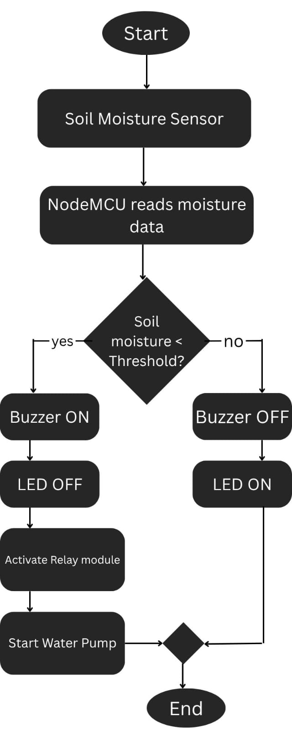
Fig 1:Flowchart of smart irrigation system
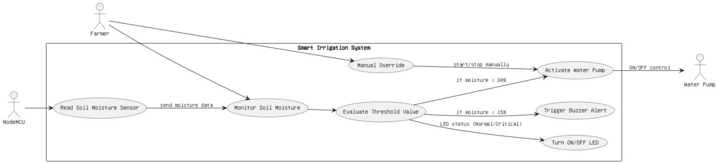
Fig 2 : Use Case Diagram of Smart irrigation system
A smart irrigation system using IoT is designed to optimize water usage and enhance crop management by automating irrigation based on real-time environmental data. It integrates a network of sensors, such as soil moisture, temperature, humidity, and rainfall detectors, to monitor conditions and send data to a microcontroller like ESP32 or Arduino. The system analyzes this data against predefined thresholds to decide when and how much water is needed. Actuators such as water pumps and valves are then triggered to deliver precise amounts of water through sprinklers or drip systems to specific zones, reducing waste and improving efficiency.
The system is connected to the internet via IoT communication modules, such as wi-fi, or GMS, enabling remote monitoring and control through a cloud-based platform. Users can access a mobile app or web dashboard to view real-time data, adjust settings, or manually override operations. Additionally, the cloud stores historical data for advanced analytics, allowing predictive insights for better crop planning. Solar panels with battery backup can power the system in off-grid areas, making it sustainable and suitable for remote farming applications.
This smart system not only automates irrigation but also provides alerts for anomalies, such as sensor failures or low water levels. By optimizing water use and offering remote access, it reduces labor, enhances productivity, and supports sustainable agriculture. However, challenges like initial costs, maintenance, and connectivity in rural areas must be addressed to ensure its effectiveness and scalability.

3.1 Requirement Analysis
The required parts are listed as follows:
i) NodeMCU ESP8266:
NodeMCU is a microcontroller unit and an open-source platform which can connect objects and let data transfer using the Wi-Fi protocol. It can solve many of the IoT projects needs alone.
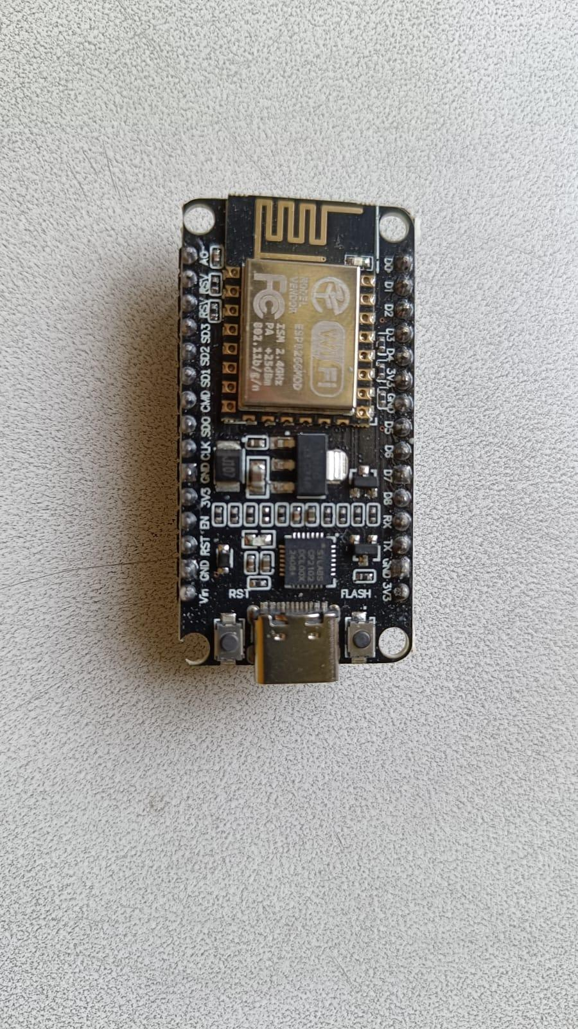
Fig 3 : NodeMCU

II) Soil Moisture Sensor
Soil moisture sensors are devices that monitor the amount of water in the soil. They track changes in another soil parameter that is predictable in relation to water content.
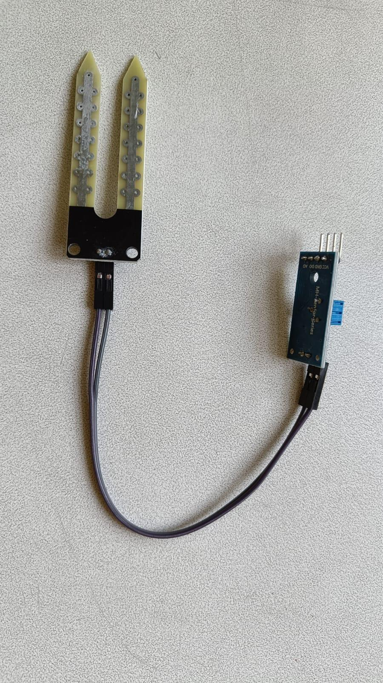
Fig 4 : Soil Moisture

III) Water Pump (5V)
Water pump are machines for pumping water. This pump is used to pump water to the fields. This motor operates in 5V DC power.
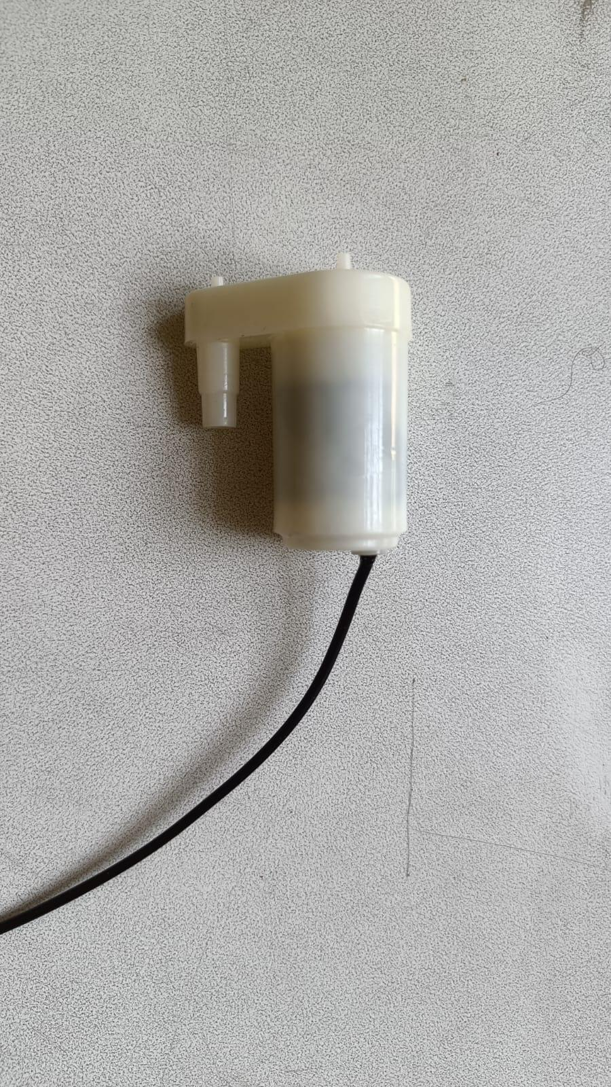
Fig 5 : Water pump

IV) Breadboard
A breadboard is a rectangular board with numerous mounting holes that is used to prototype electronics and test circuit designs without the use of wire. Before finishing any circuit design, a breadboard is used to quickly develop and test circuits
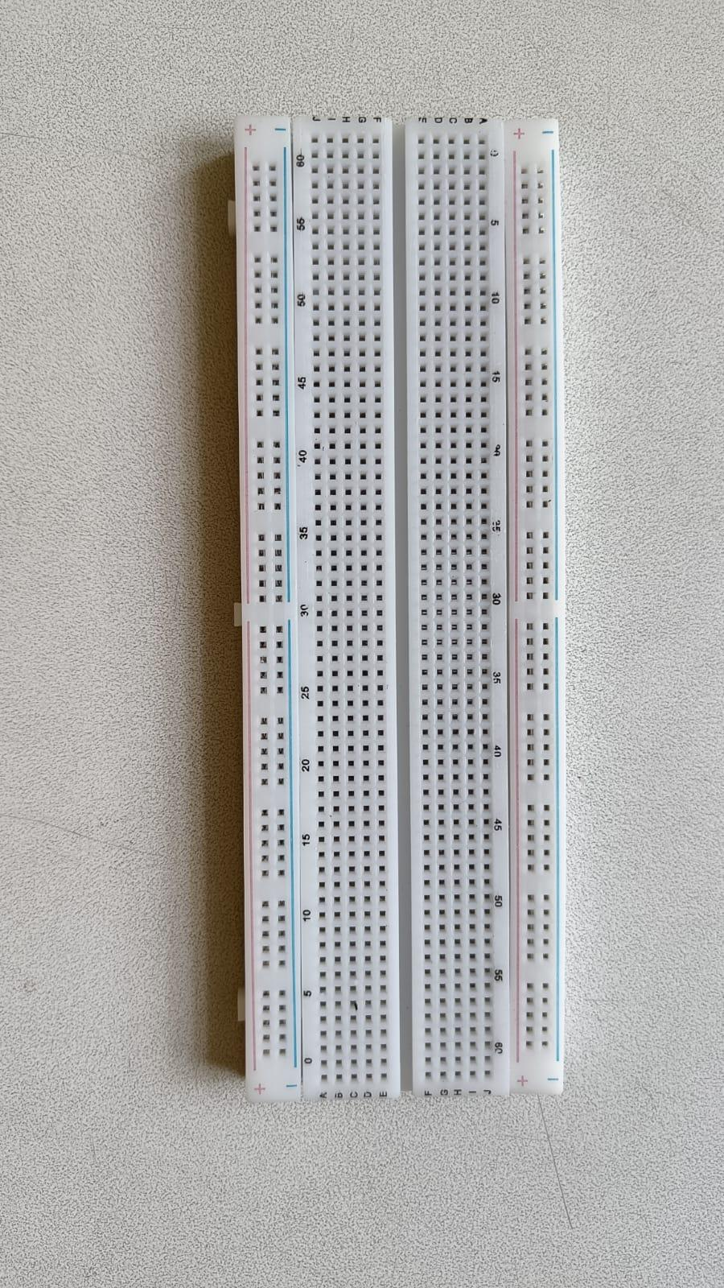
Fig 6 : Breadboard

V) Jumper Wires
Jumper wires are used in circuits to link two places. Often used in conjunction with breadboards and other prototyping tools to make it simple to update a circuit as needed.
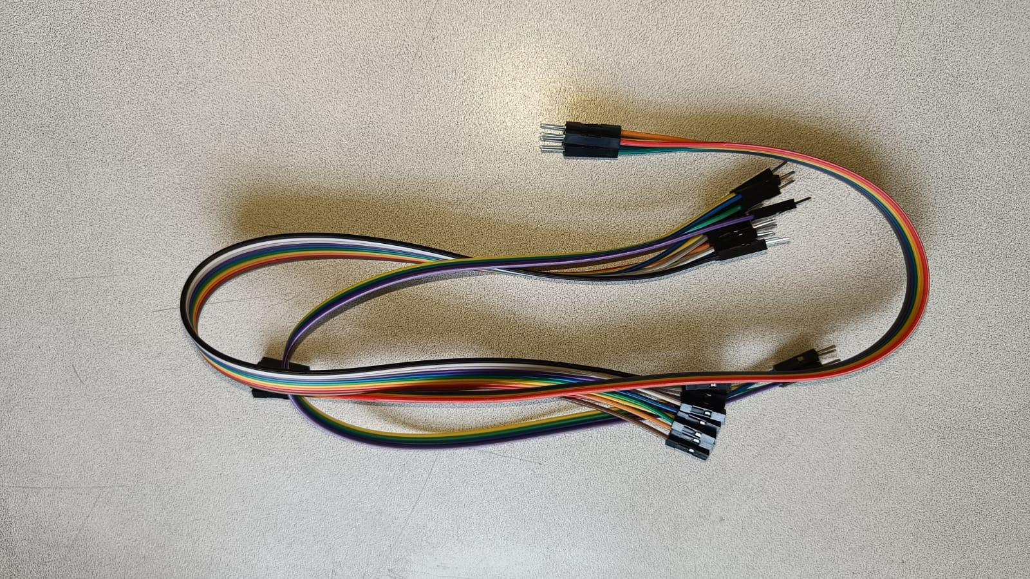
Fig 7 : Jumper wires

VI) Relay Module
Relay Module is an amazing module that helps to control another circuit using a small circuit. DC circuit can be used to close the circuit of a high voltage DC or an AC circuit.

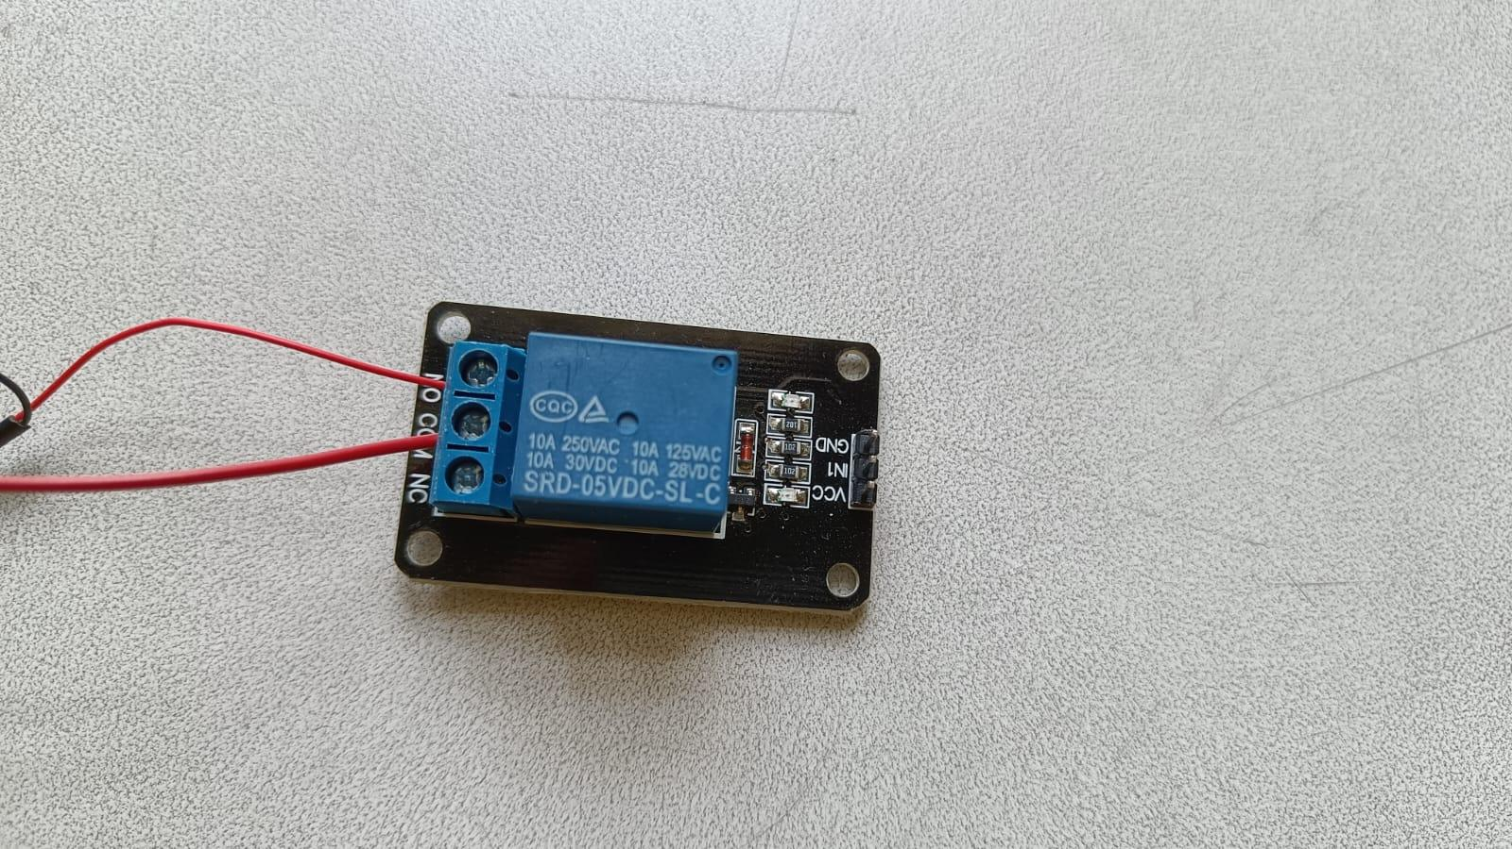
Fig 8 : Relay Module
VII) Buzzer
A buzzer is an electronic device that produces sound when electrical power is applied. It is commonly used in devices such as alarms, timers, and electronic toys to create beeping or alert sounds. There are two main types: active buzzers, which sound when power is applied, and passive buzzers, which require a signal to produce sound.

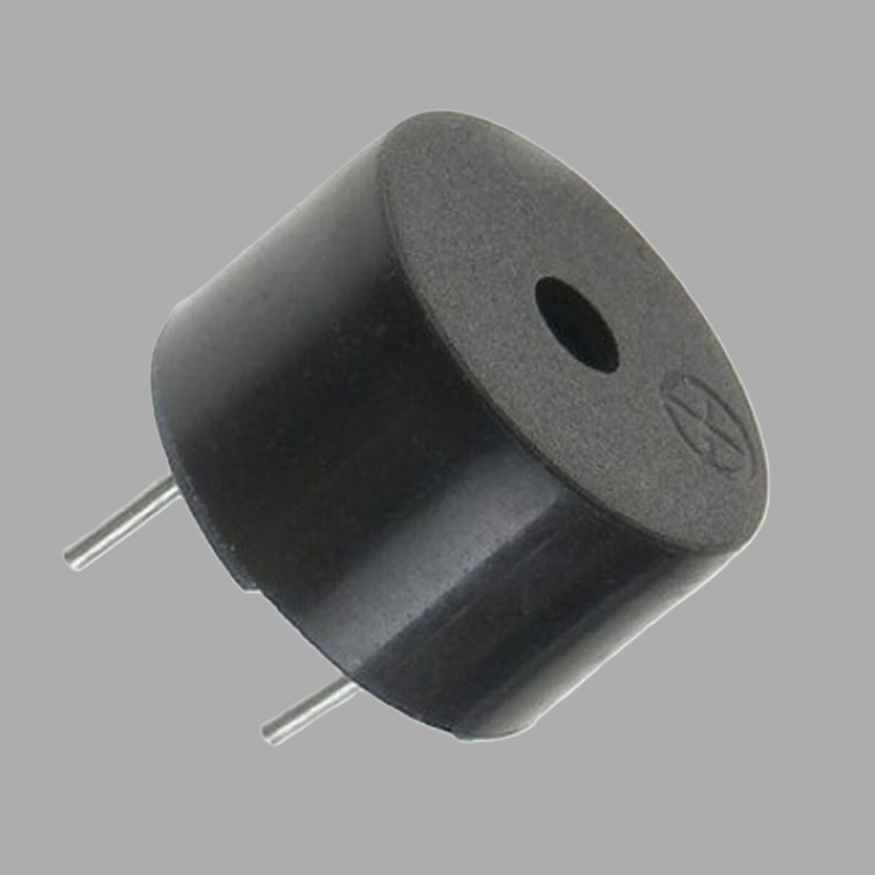
Fig 9 : Buzzer

VII) LED
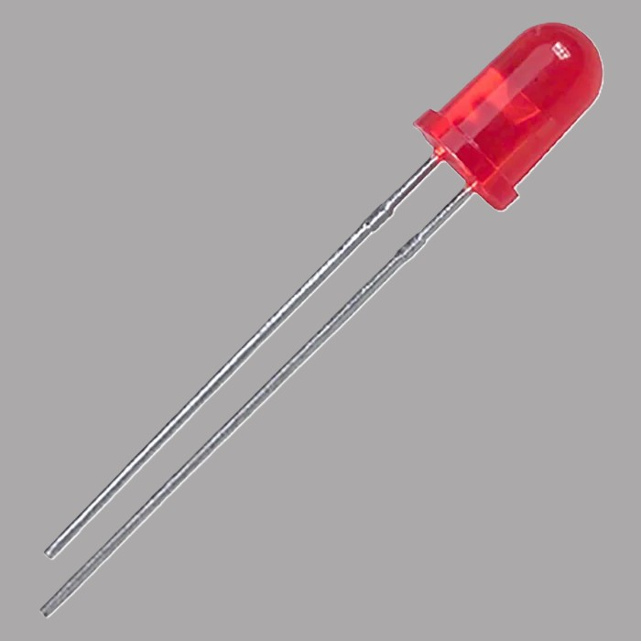
An LED (Light Emitting Diode) is an electronic component that gives off light when electricity flows through it. It is widely used in indicators, displays, flashlights, and decorative lighting. LEDs are energy-efficient, long-lasting, and come in different colors based on the materials used.

Fig 10 : LED
The required software are:-
I) Arduino IDE:

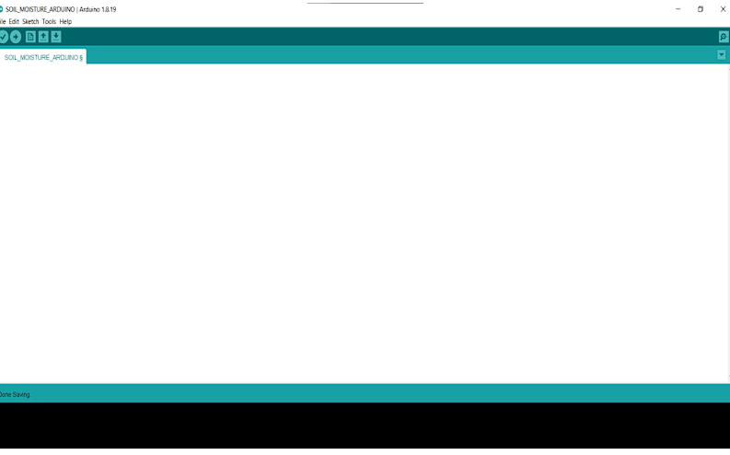
Fig 11 : Arduino IDE

Arduino IDE is an open-source electronic platform based on easy-to-use hardware and software. Arduino boards can read inputs, light on a sensor, a finger on a button and turn it into an output.
II) C++ language :
In this project we are using C++ because it has better memory management and can be used on a large scale if needed.
III) Blynk
It allows us to quickly build a monitoring interface for our project.

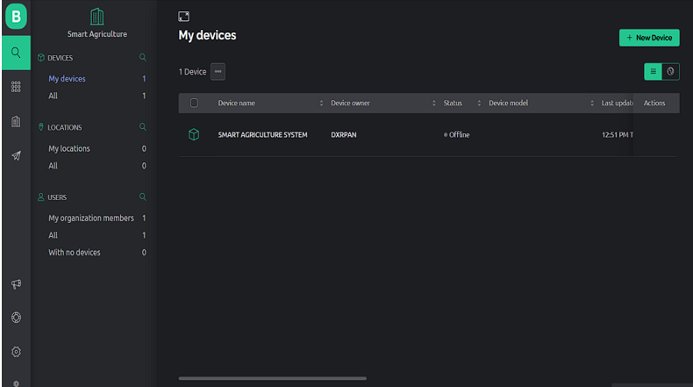
Fig 12 : Blynk

IV)Flask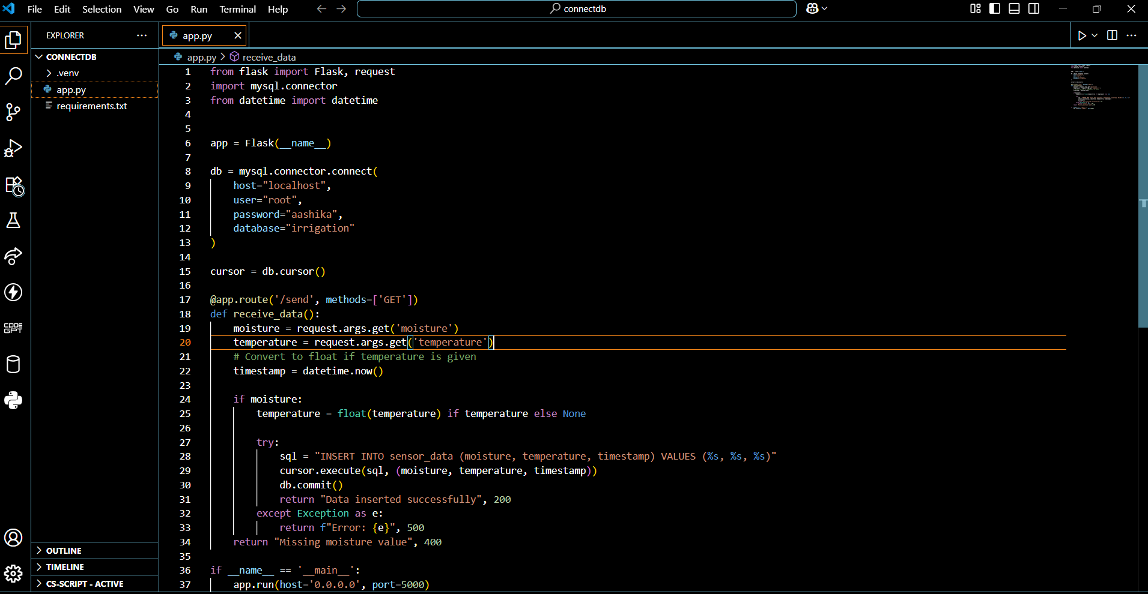
Fig 13 : Flask

Flask is a lightweight python web framework used to build web servers and APIs. It helps connect IoT devices to web apps or databases for real-time data handling. It's simple, fast, and ideal for small projects.

Chapter 4:Implementation and Discussion
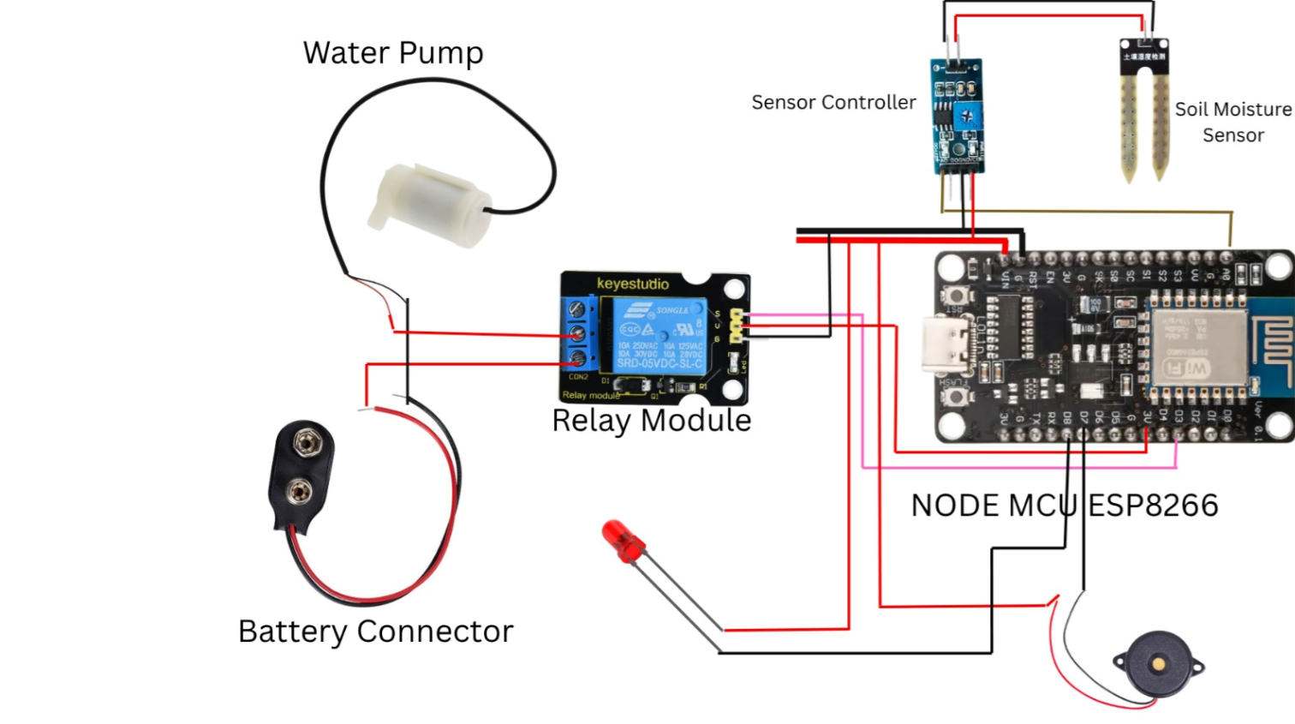
Fig 14 : Board Diagram of Smart Irrigation System

This smart irrigation system is designed to automatically water plants when the soil becomes dry. The main components used in the system are the NodeMCU ESP8266, a soil moisture sensor, a relay module, a water pump, a battery connector, an LED, and a buzzer.

First, the soil moisture sensor is placed into the soil to continuously monitor the moisture level. This sensor is connected to a small sensor controller board, which helps in sending clean signals to the microcontroller. The VCC pin of the sensor controller is connected to the 3.3V power pin of the NodeMCU, and the GND pin is connected to the GND pin of the NodeMCU. The data output (DO) pin of the sensor controller is connected to one of the digital pins of the NodeMCU (e.g., D2). When the soil is dry, the sensor sends a LOW signal to the NodeMCU, and when the soil is wet, it sends a HIGH signal.

The NodeMCU receives this signal and acts accordingly. If the signal is LOW, meaning the soil is dry, the NodeMCU turns ON a relay module. The relay module is powered by connecting its VCC and GND to the NodeMCU. The IN pin of the relay is connected to a digital pin on the NodeMCU (e.g., D1), which is used to control the relay.

The relay module works like an automatic switch. It is connected to a water pump and a battery using the NO (Normally Open) and COM (Common) terminals. When the NodeMCU activates the relay, it closes the circuit, allowing current to flow from the battery to the water pump. This causes the pump to turn on and start watering the plants.

To give visual and sound alerts during operation, an LED and a buzzer are connected to the NodeMCU. These components are also powered through digital pins (e.g., D5 for LED and D6 for buzzer). When watering starts, the LED lights up and the buzzer makes a sound. This indicates that the system is actively irrigating the soil.

As the water is supplied, the moisture in the soil increases. When the sensor detects that the soil is now wet, it sends a HIGH signal to the NodeMCU. The NodeMCU then turns OFF the relay, which stops the water pump. The LED and buzzer are also turned off, indicating that the watering process is complete.

In summary, the system uses sensor input to detect dry soil and activates the pump using a relay. Once the soil becomes moist, the system automatically stops the pump. This entire process is automatic and helps to conserve water, reduce manual effort, and ensure plants get the right amount of water when needed. This setup can also be enhanced by adding Wi-Fi features through the NodeMCU to monitor or control the system remotely via mobile or web applications.

4.1 Methodology
To develop our Smart Irrigation System using IoT, we followed a step-by-step approach combining both hardware and software components. We first designed the system using a soil moisture sensor, NodeMCU ESP8266, and a relay module to control a water pump. The components were connected on a breadboard and powered with a 9V battery for initial testing. We used the Arduino IDE to program the NodeMCU in C/C++. The algorithm reads moisture levels from the sensor and powered with a 9V battery for initial testing. We used the Arduino IDE to program the NodeMCU in C/C++. The algorithm reads moisture levels from the sensor and compares them to a set threshold. If the soil is too dry, the relay turns the pump ON; otherwise, it remains OFF. The logic was tested using the serial monitor with different soil conditions (dry, moist, and wet).Tools and Technologies Used:
Hardware: NodeMCU, soil moisture sensor, relay module, 9V battery, buzzer ,LED
Software: Arduino IDE, Flask ,mysql
Language: C++
We are currently working on connecting the system to an online database to store and monitor real-time data. Once integrated, it will enhance the system’s functionality by allowing remote access and data logging.

4.2 Implementation steps
Component Collection: We gathered all necessary components including NodeMCU ESP8266, soil moisture sensor, relay module, jumper wires, breadboard, and a 9V battery.
Circuit Design: We connected the soil moisture sensor to the NodeMCU to read real-time soil data. The relay module was connected to control the water pump (or a simulated load), and all components were arranged on a breadboardProgramming the NodeMCU: We wrote and uploaded the Arduino code to the NodeMCU. The code reads moisture levels and triggers the relay to turn the pump on or off based on a predefined threshold.
Testing and Calibration: We tested the system in different soil conditions (dry, moist, and wet) and adjusted the threshold values to ensure accurate sensor response and relay controlPower Supply Setup: A 9V battery was used to power the system, and we checked its performance under continuous operation.

Final Integration: All components were securely arranged, and the full system was tested as a unit to confirm its functionality and reliability.

4.3 Output Obtained
The Smart IoT-based Irrigation System project was completed successfully with the following outcomes:
Hardware Implementation
- All required components including the NodeMCU (ESP8266), soil moisture sensor, relay module, water pump, buzzer, LED, and a 9V battery were collected and properly assembled.
- The circuit was tested on a breadboard to verify all electrical connections and ensure stability.
- The soil moisture sensor accurately detected moisture levels in both dry and wet soil conditions.
- The relay module responded effectively to changes in soil moisture, activating or deactivating the pump as required.
- A buzzer was integrated into the circuit to produce an audible alert when the soil became too dry.
- An LED was used as a visual indicator, turning on when the soil was sufficiently moist and off when dry.
IoT Features via Blynk Platform:
- The Blynk mobile application was successfully configured to display live soil moisture readings.
- Users were able to remotely control the water pump through the mobile interface.
- Real-time alerts were generated when the soil moisture dropped below the defined threshold.
- A cloud database was used to store sensor data for monitoring and analysis.
- Stable communication was established between the NodeMCU, Blynk platform, and mobile device, ensuring seamless operation.
Testing Results
Testing was carried out by placing the soil sensor in both dry and wet soil samples, confirming accurate readings.
The buzzer and LED provided appropriate feedback based on sensor data.
Power supply from a 9V battery was sufficient for stable testing.
The system automatically initiated irrigation when soil dryness exceeded the critical threshold and stopped watering once the moisture level was restored.
Screenshots and Visuals:
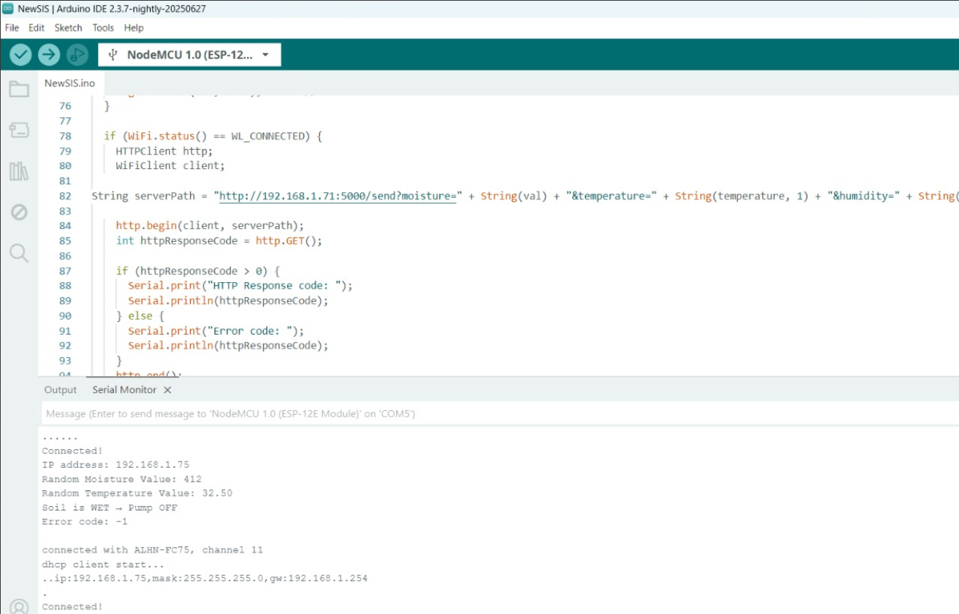
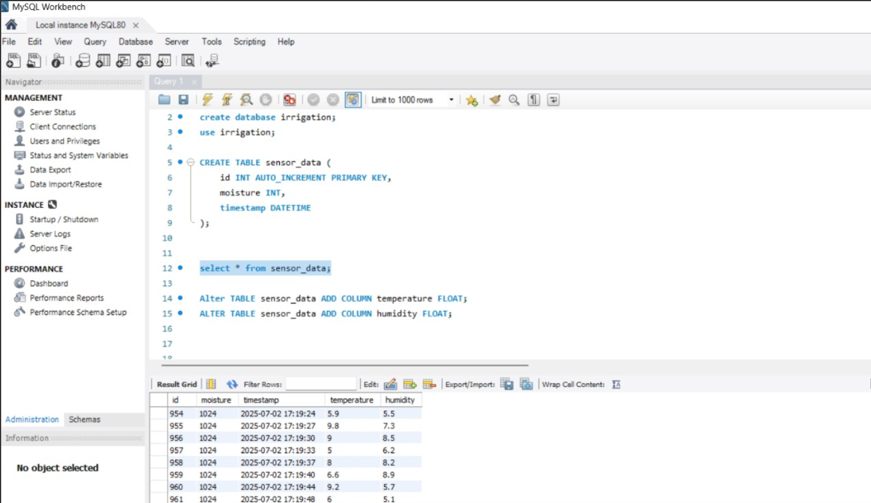
Fig 15 : OUTPUT

4.4 Testing/Test Cases
Table of test case
Test Case ID | Test Level | Test Objective | Test Steps | Expected Result | Actual Result
TC1 | Sensor Level | Verify correct detection of soil condition | 1. Insert sensor in dry soil  2. Record reading  3. Insert in wet soil  4. Record reading | High reading for dry, low for wet | Readings matched expected values
TC2 | Logic Level | Check if system starts/stops irrigation based on moisture | 1. Simulate dry soil  2. Check if irrigation starts  3. Simulate wet soil  4. Check if irrigation stops | Starts irrigation at 600  Stops at 400 | System behaved correctly
TC3 | Component level | Ensure relay opens/closes water valve correctly | 1. Send ON command  2. Observe valve  3. Send OFF command  4. Confirm water stops | Valve opens on ON, closes on OFF | Relay switched valve correctly
TC4 | System Level | Test automatic watering based on sensor input | 1. Let soil dry  2. Watch for auto irrigation  3. Let soil become wet  4. Ensure irrigation stops | System turns ON at dry, OFF at moist | Automated cycle worked correctly
TC5 | IoT & Interface | Verify remote monitoring and control | 1. Connect NodeMCU to Blynk  2. Send commands  3. Monitor real-time data | Blynk shows data & controls motor | Blynk operated successfully

4.5 Time Schedule
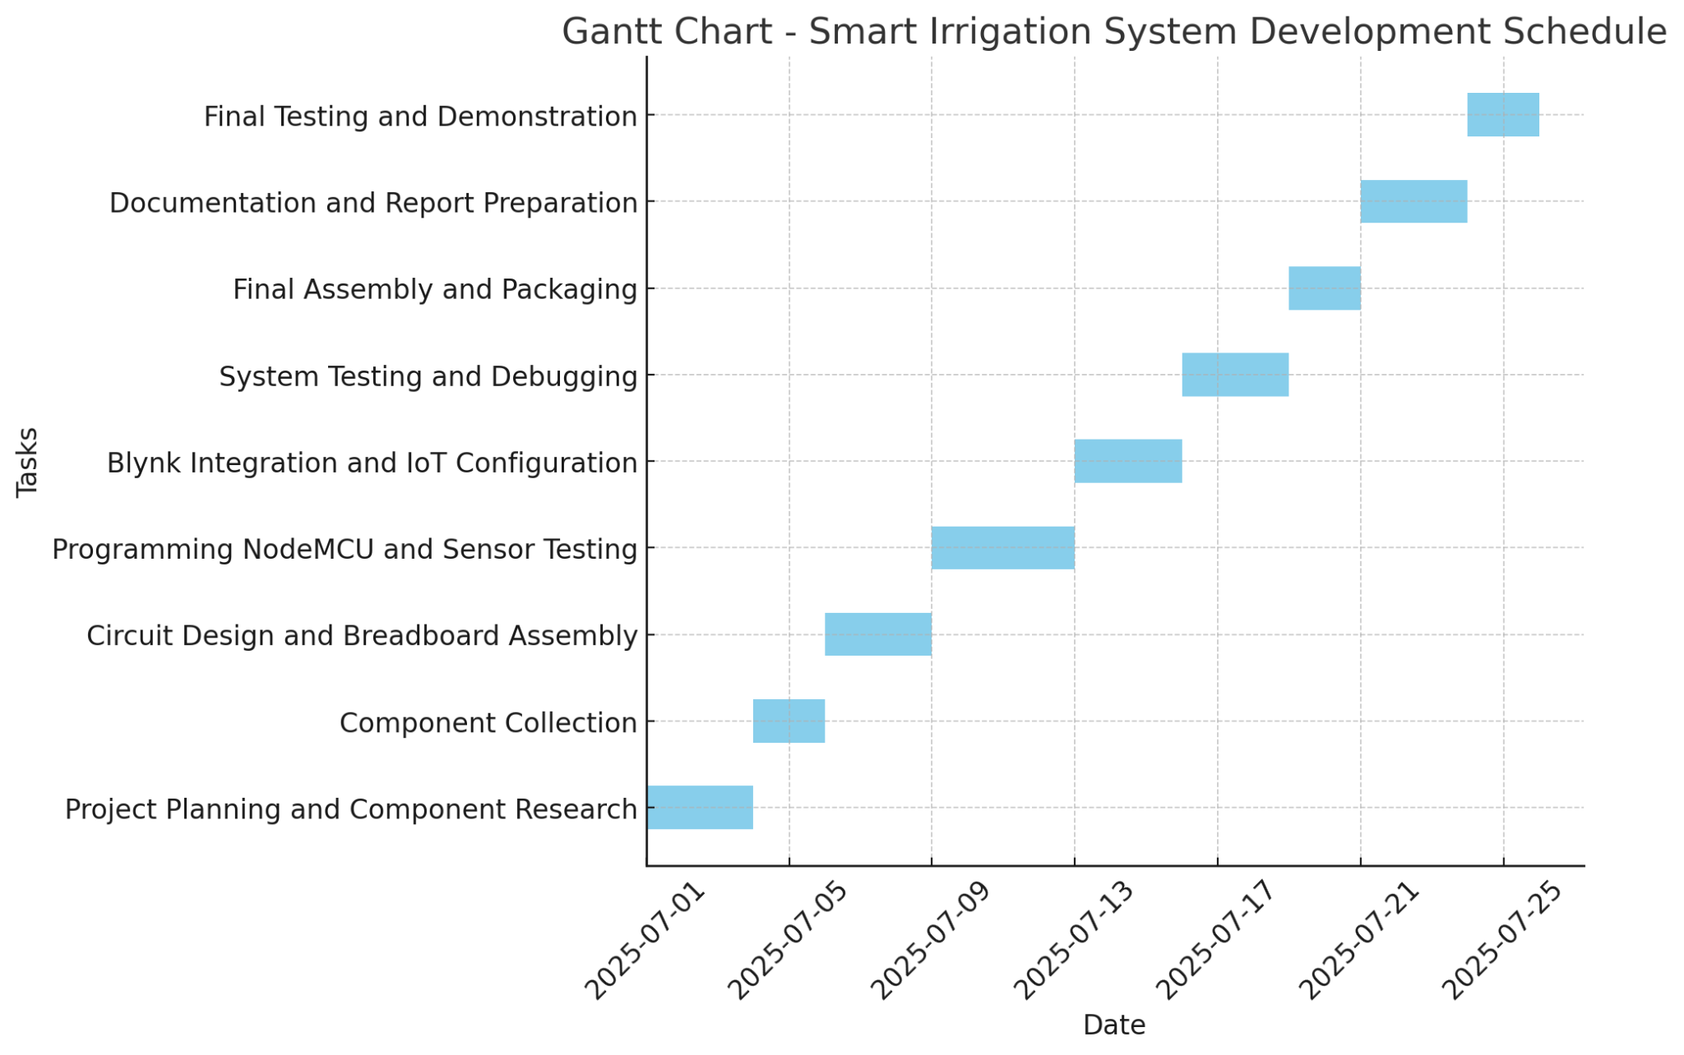
Fig 16 : Time Schedule
The time schedule for the development of the Smart IoT-based Irrigation System was carefully planned and followed using a Gantt chart to ensure that each phase of the project was completed on time. The entire development process was divided into specific tasks, each assigned with a defined duration and sequence.

Textual Description
- Project Planning and Component Research
The initial phase focused on understanding project requirements, selecting suitable sensors and modules, and designing the system structure.
- Component Collection
All necessary hardware components such as NodeMCU, soil moisture sensor, relay module, water pump, buzzer, and LED were collected.
- Circuit Design and Assembly
The system was assembled on a breadboard. Electrical connections were tested for correctness and stability.
- Programming and Sensor Testing
The NodeMCU was programmed using Arduino IDE. The soil moisture sensor was tested to ensure accurate readings.
- Blynk Integration
The Blynk platform was configured to allow remote monitoring and control. Real-time data display and pump control were implemented.
- System Testing and Debugging
The full system was tested under different conditions. Bugs and errors were identified and resolved.
- Final Assembly and Packaging
The hardware was permanently mounted on a suitable base or casing for final presentation.
- Documentation and Report Writing
A detailed report was prepared summarizing each stage of the project along with output screenshots.
- Final Testing and Demonstration
The entire system was tested one last time and demonstrated to showcase functionality, accuracy, and automation features.

Chapter 5:Analysis and Evaluation

5.1 Data Analysis

Key Findings from Data
- Accurate Sensor Readings:
The soil moisture sensor reliably detected both dry and wet soil conditions during testing.
- Automated Irrigation Control:
The system automatically turned the pump on when soil moisture dropped below the threshold and turned it off when moisture was sufficient.
- Effective Remote Monitoring:
The Blynk mobile app displayed real-time moisture levels and allowed remote control of the water pump.
- Quick System Response:
The pump, buzzer, and LED responded quickly and correctly based on sensor inputs.
- Water Efficiency Achieved:
Water was used only when needed, helping reduce wastage and promoting sustainability.
- Stable IoT Connectivity:
The NodeMCU maintained consistent communication with the Blynk platform without any disconnection issues.
The data collected from the smart irrigation system demonstrated accurate soil moisture detection and reliable automation of water control. The system efficiently activated and deactivated the water pump based on real-time moisture levels, ensuring proper irrigation without manual effort. Remote monitoring through the Blynk app functioned smoothly, providing timely updates and control access. Additionally, the buzzer and LED offered clear feedback on soil status. The system showed fast response times and stable IoT connectivity, resulting in optimized water usage and promoting sustainable resource management.

5.2 Results
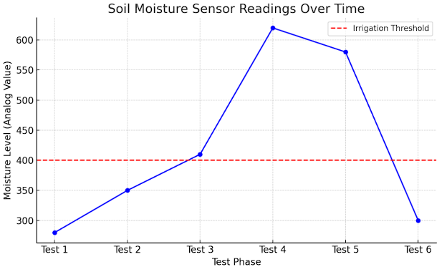
Fig 17 : Result

Visual Representation

The graph above shows the soil moisture sensor readings recorded during various test phases. The red dashed line indicates the predefined irrigation threshold (analog value = 400).
Table of results
Test Phase | Moisture Level (Analog value) | Pump Status
Test 1 | 280 | OFF
Test 2 | 350 | OFF
Test 3 | 410 | ON
Test 4 | 620 | ON
Test 5 | 580 | ON
Test 6 | 300 | OFF

Discussion of Observations
- During Tests 1, 2, and 6, moisture levels were below the threshold (400), and the pump was deactivated.
- In Tests 3, 4, and 5, the moisture levels exceeded the threshold, and the pump remained on, indicating proper automation.
- A clear pattern is observed where the system accurately responds to moisture changes by turning the pump on or off.
- No significant anomalies were found during testing. The sensor data behaved consistently with environmental conditions.

5.3 Comparison with Objectives:
Table of objective and evaluation
Objectives | Evaluation
To learn about different devices like node, soil moisture sensor, and water motors. | Met: The project involved hands-on use and integration of all key devices, enhancing understanding of each component’s function.
To develop a system that waters the soil by monitoring its moisture using sensors. | Met: A functional system was built that monitors soil moisture and controls watering based on real-time data
To apply hardware, software, and programming knowledge in an IoT project. | Exceeded: Not only were programming and circuit-building skills applied, but debugging, calibration, and system design skills were also practiced.
To implement automated irrigation that adjusts water based on crop needs and reduces water waste. | Met: The system responds accurately to soil dryness, ensuring water is only used when needed—reducing wastage effectively.
To automate the irrigation system. | Met: The system operates without manual intervention, completing the automation goal.

5.4 Discussion of Findings
The implementation of the smart irrigation system revealed several significant findings related to automation, efficiency, and real-time monitoring. The soil moisture sensor effectively detected changes in soil moisture levels, allowing the relay module to control the water motor with high accuracy. The integration of the buzzer and LED provided real-time audio-visual feedback, enhancing user awareness of soil conditions. Using the Blynk platform, the system successfully transmitted live data to the user’s mobile device, enabling remote monitoring and control, which is crucial for modern agricultural practices. The NodeMCU communicated reliably with both the database and Blynk, confirming the system’s stability under IoT-based operations.
The project demonstrated that automation in irrigation not only reduces manual effort but also significantly conserves water by operating only when necessary. During testing, the system responded accurately to varying soil conditions, showing high potential for field applications. However, it was observed that system performance could be limited by power supply constraints and internet connectivity. Despite these, the integration of hardware and software components was smooth and efficient, showcasing the practicality of IoT in agriculture. Overall, the findings affirm that the system meets its design goals, with room for further improvement in scalability and environmental resilience.

Chapter 6:Conclusion and Future Work

A smart irrigation system using soil moisture sensors ensures water is applied only when needed by monitoring moisture levels in the soil. The system automatically adjusts watering schedules based on the data from these sensors, preventing overwatering and reducing water waste. This leads to healthier plants, better crop yields, and lower water costs. By delivering water precisely when the soil reaches a critical dryness threshold, it promotes efficient resource use and sustainability. The system also helps save time and effort by automating irrigation and reducing the need for manual monitoring and watering.

The smart irrigation project has been successfully completed with all planned objectives and tasks fully achieved. Initially, all required components—including the NodeMCU, soil moisture sensor, relay module, water motor, buzzer, and LED—were collected. The circuit was properly assembled and tested on a breadboard, confirming that all electrical connections functioned correctly. The soil moisture sensor readings were accurate, and the relay module responded as expected to moisture level changes. A 9V battery was used for basic power testing, which verified the system’s operational stability. A buzzer was integrated to alert when the soil is too dry, while an LED provided a visual status indicator, enhancing system feedback. The system was connected to a real-time database, and Blynk was used for integrating a mobile interface, allowing users to monitor live soil moisture and control the pump remotely. IoT features such as remote monitoring, data logging, and real-time alerts were successfully implemented through Blynk and cloud communication. Stable interaction between NodeMCU, the database, and the Blynk platform ensured seamless control and visibility. Final testing confirmed the system’s reliability, automation, and practical utility, marking the successful completion of a fully functional smart irrigation system.

References
- (2023). Automatic irrigation system using arduino uno. International Journal of Progressive Research in Engineering Management and Science. https://doi.org/10.58257/ijprems31943
- (2024). Automatic irrigation system with remote monitoring facility. International Research Journal of Modernization in Engineering Technology and Science. https://doi.org/10.56726/irjmets48079
- Asha, Y. (2019). Smart irrigation system using internet of things. International Journal for Research in Applied Science and Engineering Technology, 7(5), 3346-3351. https://doi.org/10.22214/ijraset.2019.5550
- Efremova, N. (2019). Prediction of soil moisture content based on satellite data and sequence-to-sequence networks. https://doi.org/10.48550/arxiv.1907.03697
- García, L., Parra, L., Jiménez, J., Parra, M., Lloret, J., Mauri, P., … & Lorenz, P. (2021). Deployment strategies of soil monitoring wsn for precision agriculture irrigation scheduling in rural areas. Sensors, 21(5), 1693. https://doi.org/10.3390/s21051693
- Jaguey, J., Villa-Medina, J., Lopez-Guzman, A., & Porta-Gándara, M. (2015). Smartphone irrigation sensor. Ieee Sensors Journal, 15(9), 5122-5127. https://doi.org/10.1109/jsen.2015.2435516
- Lin, L., Gu, W., Li, X., & Shen, G. (2017). Soil moisture monitoring system based on wireless sensor network. https://doi.org/10.2991/isaeece-17.2017.73
- Okasha, A., Ibrahim, H., Elmetwalli, A., Khedher, K., Yaseen‬‬‬‬‬‬‬‬‬‬‬‬‬‬‬‬, Z., & Elsayed, S. (2021). Designing low-cost capacitive-based soil moisture sensor and smart monitoring unit operated by solar cells for greenhouse irrigation management. Sensors, 21(16), 5387. https://doi.org/10.3390/s21165387
- Placidi, P., Gasperini, L., Grassi, A., Cecconi, M., & Scorzoni, A. (2020). Characterization of low-cost capacitive soil moisture sensors for iot networks. Sensors, 20(12), 3585. https://doi.org/10.3390/s20123585
- Pramanik, M., Khanna, M., Singh, M., Singh, D., Sudhishri, S., Bhatia, A., … & Ranjan, R. (2023). Evaluation of capacitance-based soil moisture sensors in iot based automatic basin irrigation system. https://doi.org/10.21203/rs.3.rs-3043138/v1
- Sunehra, D. (2019). Web based smart irrigation system using raspberry pi. International Journal of Advanced Research in Engineering & Technology, 10(2). https://doi.org/10.34218/ijaret.10.2.2019.006

